FSE project Documentation

Git Repository link: <https://github.com/hariharan1789/taskMgmt_FSE>

Attached Load testing report and code coverage report in the Git repository link

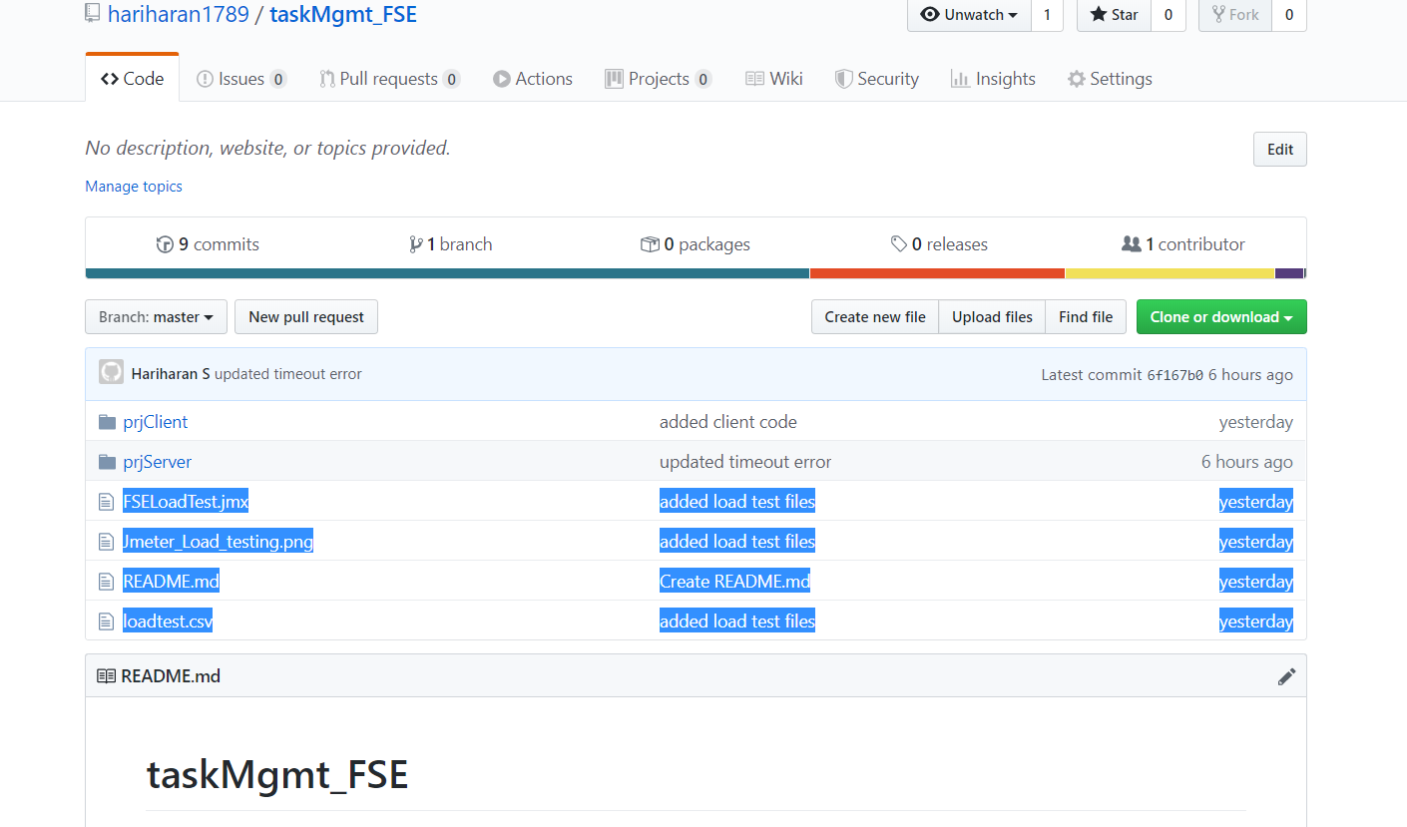

1. To run the application: Run Mongod.bat in desktop to start the mongo DB

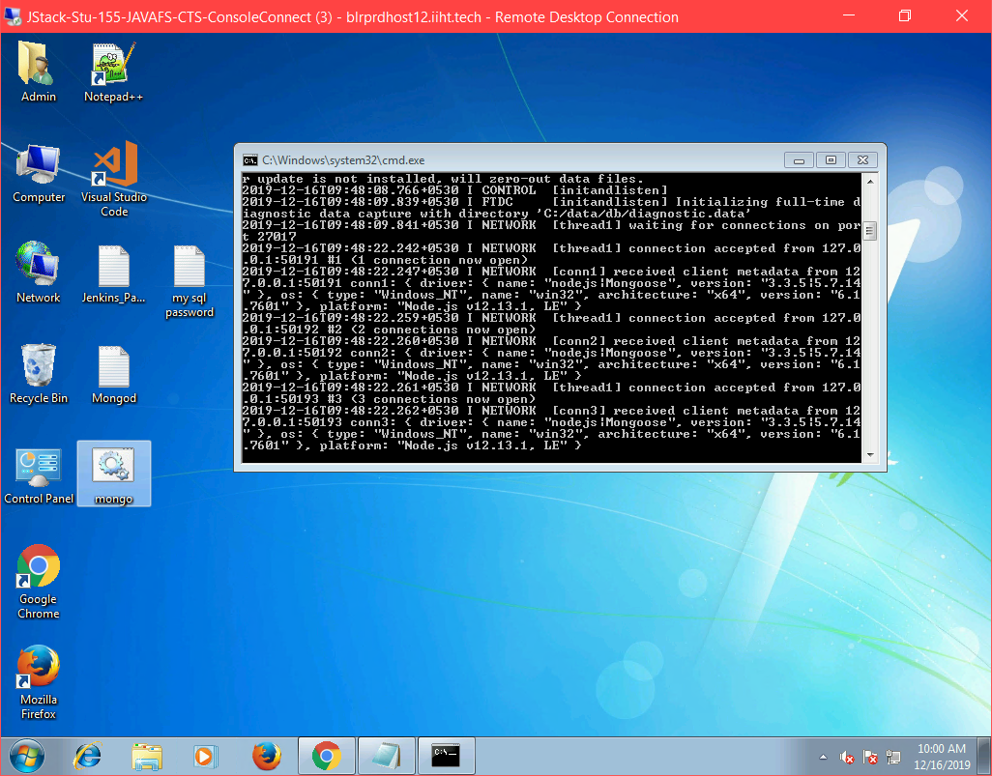

1. In Jenkins, select “start server” and build to run server programs and connect to MongoDB
2. Then select “fseproj” and select build to run client application.
3. Jenkins admin password will be available in Desktop

Then goto link

localhost:4200 to launch the application

* Code coverage will be present in prjClient/coverage/index.html